ISM 6251 and 4543: Machine Learning (Fall 2025)

Assignment 2

- Please provide succinct answers to the questions below.
- You should submit a .ipynb file and a pdf (for any non-coding questions) in Canvas.
- Please include the names of all team-members in your write up and in the name of the file. One submission per group.
- You should include all the Python functions you use.

Problem 1. The dataset income_data.csv represents an extract from a commercial marketing database. You can find the column description in income_info.txt. The goal is to fit a decision tree to predict the annual income of a household from 13 demographic attributes and interpret the results. We want to use Python to construct a decision tree to fulfill this task. Please answer the following questions.
- Without using a decision tree, investigate the relation between the annual income and the other demographic predictors. Write a short summary of your observations. Which variables seem to be useful for predicting income? Why?

The Chi-Square test revealed that all variables have very low p-values (<0.001), meaning that every demographic attribute shows some statistically significant association with annual income.

Cramer’s V helped us to assess the strength of these associations:

Strongest association:
- Householder_Status (0.456) → Owning vs renting vs living with family. Owners likely have higher income brackets.

Moderate associations:
- Age (0.279) → Income increases with age up to mid-career, then may flatten or decline.
- Education (0.265) → Higher education (college/grad study) aligns with higher income.
- Marital_Status (0.262) → Married vs divorced vs single shows clear differences.
- Occupation (0.228) → Professional/managerial roles align with higher income compared to homemaker, unemployed, or laborer.

Weaker associations:
- Household_Size (0.107), Home_Type (0.151) → Larger households or certain home types carry some signal but weaker.
- Sex (0.050), Years_in_Area (0.048), Ethnicity (0.069), Language (0.091) → Very weak effects; not strong predictors.

Finally, the correlation heatmap allowed for an overall assessment of direction and trend for ordinal variables. Here are some examples of positive correlations (higher income associated with higher category codes):
- Education (0.45) → More education = higher income.
- Age (0.45) → Older respondents generally have higher income, especially 25–54 groups.

Therefore, the most useful predictors of income are householder status (own vs rent vs family), marital status (married vs single/divorced), education level, occupation type, age group, and dual income.

- Divide your data into 60% train and 40% test. Create the default C&R decision tree. How many leaves are in the tree? What is the size of each leaf node?

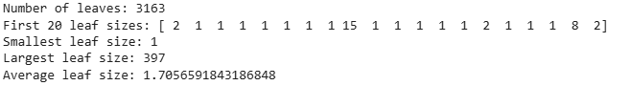

- What are the major predictors of income? How are they related to your observations in part (a)? How well
your decision tree can predict a household’s income in your training data?

The major predictors were Age, Occupation, Household Size, Ethnicity and Education. While comparing decision tree outcomes with our initial analysis, both methods agree that Age and Occupation are strong predictors. Nevertheless, the tree emphasizes Household Size and Ethnicity more, which may be an artifact of overfitting. Education is still high on both lists, though the tree ranks it a bit lower. It is worth noting that the variables with the strongest Cramer’s Vs (Householder Status and Dual Income), were ranked the lowest in the default tree. Finally, the tree fits training data very well (91%) but fails on test data (28%), showing severe overfitting.

- Give two decision rules that are useful for predicting income. Justify your choice.

- If Education ≥ 5 (College Graduate or Grad Study) AND Occupation ≤ 2 (Professional/Managerial or Sales Worker), then Annual_Income ≥ 7 (≈ $40k+).
- If Age ≤ 2 (≤ 24 years old) AND Household_Size ≥ 4, then Annual_Income ≤ 2 (≤ $15k).

Justification: The rules capture both ends of the income spectrum: Rule 1: predictors of higher income. Rule 2: predictors of lower income. The tree tends to split early on Occupation and Education for higher-income categories, whereas Age (0.153) is the most important predictor. Younger respondents (≤24) are often students or early-career individuals with lower income. If the household is large (≥4 people) but the respondent is young, this likely reflects a single, low-earning individual still living with parents/family.

- Using your decision tree, predict the annual income of the households in the test data. What is the error of your predictions?

- Describe the profile/characteristics of the households in your training data that are likely to have high income.

Based on the analysis outputs and the crosstabs report, a high-income household (classes 7–9) would likely present the following traits for the six major predictors identified:

- Age: 35–64 (prime earning years)
- Education: College degree or graduate study
- Occupation: Professional/Managerial (or Sales)
- Housing: Owns a home, usually a house
- Household Size: Moderate (2–4 people)
- Tenure: Long-term residents (>10 years in the area)

- The dataset income_big.csv consists of the marketing database with 10 spurious variables added. Each of the added variables takes integer values from 1 to 9 with equal probability (very often in data mining datasets there are predictors that are not related to the response variable). Run a C&R tree model using this data and compare your results with those of problem (c).

When comparing the Original CART (14 demographic predictors) with the BIG CART (14 demographics + 10 spurious predictors), we see clear evidence of overfitting in both models, with the effect amplified by the spurious variables. The Original CART achieved very high training accuracy (91%) but only 28% accuracy on the test set, indicating it memorized much of the training data (error gap of ~63%). It also grew quite large, with a depth of 28, over 6,300 nodes, and more than 3,100 leaves, many of which were very small (average leaf size ~1.7 samples).

The BIG CART, by contrast, fit the training data perfectly (100% training accuracy, 0% error), but its test performance dropped further to ~25% accuracy and a macro F1 of 0.21. The model became somewhat shallower (depth 25) and smaller in total size (3,559 nodes, 1,780 leaves), with slightly larger average leaf size (~2.2 samples). However, its test error rose to ~75%, showing that the inclusion of spurious variables worsened generalization.

- Create two more C&R trees. Change the parameters of the tree such that you get a tree as large as possible (minimum-pruning). The other does prune with making sure you require at least 500 records in a parent nodes and 100 records in leaf nodes. How do the trees differ (briefly explain). Which seems more accurate on the training data? Which seems more accurate on the test data?

Max-size tree: Very deep (depth 28) with 6,325 nodes and over 3,100 leaves, many containing just 1–2 records (avg leaf size ≈1.7). This is a highly complex tree that memorizes the training data.

Pruned tree: Very shallow (depth 6) with only 35 nodes and 18 leaves, each leaf much larger (avg ≈300 records, minimum 166). This model is far simpler and more generalized.

Max-size tree is far more accurate on training (91% vs. 35%). This shows it overfits, fitting almost every training example perfectly. The Pruned tree is slightly more accurate on the test set (33% vs. 28%). Even though its training accuracy is much lower, pruning prevents overfitting and allows it to generalize a bit better. This highlights the trade-off between model complexity (variance) and generalization (bias).

- In this part we want to check the effect of the size of training and testing data on the quality of the predictions. Construct a decision tree on different size of training data and compare the results. For example, consider a partition of the data into 50% for Training and 50% for Testing. What model performance do you obtain? Consider partitions of the data into 70% for Training and 30% for Testing, and 90% for Training and 10% for Testing and report on model and performance comparisons. Feel free to experiment with other size partitions on the data. Is there any specific model you would prefer to implement? Explain your reasoning.

Performance Summary of Trees Constructed:
- 50/50 split: Train 0.918 / Test 0.269, depth 33, ~2.7k leaves.
- 70/30 split: Train 0.902 / Test 0.283, depth 33, ~3.7k leaves.
- 90/10 split: Train 0.894 / Test 0.284, depth 33, ~4.7k leaves.

All three trees overfit (train ≈ 0.89–0.92 vs test ≈ 0.27–0.28). As train size increases (50% → 90%), the tree grows more leaves and test performance ticks up slightly (Accuracy +~0.015, Macro-F1 +~0.015). Depth stays the same (33), and average leaf size ~1.7 across the board, which are extremely tiny (another characteristic of overfitting). As much as the 90/10 tree posts the highest test accuracy/Macro-F1, its test set is small, and the metric is thus less reliable. Therefore, 70/30 is the best practical choice: nearly the same performance as 90/10, with a more trustworthy estimate (larger test set). Nevertheless, an even better approach would be jumping to a Random Forest and evaluating it with cross-validation.

- Construct two decision trees, once using “gini” measure once using “information gain” and try to keep the
other parameters the same. Which model is better? In general, how do you choose the purity measure?

CART (Gini):
- Train Accuracy: 90.2%
- Test Accuracy: 28.3%
- Macro F1: 0.240
- Depth: 33

CART (Entropy):
- Train Accuracy: 90.2%
- Test Accuracy: 27.4%
- Macro F1: 0.230
- Depth: 24

Both models fit the training data equally well (identical accuracy). On the test data, Gini edges out Entropy by about +0.9% accuracy. Entropy produced a slightly shallower tree (24 vs. 33) with a similar number of leaves — suggesting it made more balanced splits but did not improve generalization. So, in this case, Gini performed marginally better and would be the preferred choice.

Generally, a few considerations surround the purity measure. Gini is the default in CART. It is computationally cheaper (no logarithms), but biased towards the most frequent class, which makes splits faster and results like those of entropy. Entropy tends to produce more balanced splits as seen above but is more computationally intensive. It can be helpful when capturing rare classes more precisely.

- Train a Random Forest classifier on the training data (using the same 60/40 split as in part b). Use an ensemble of 100 trees (n_estimators=100) and set random_state=42 for reproducibility. What is the Out-of- Bag (OOB) error estimate of your model?
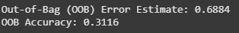

- Plot the feature importances as determined by the Random Forest model. How does the ranking of the most important features compare to the major predictors you identified in the single decision tree (part c)? Provide a brief explanation for any similarities or differences
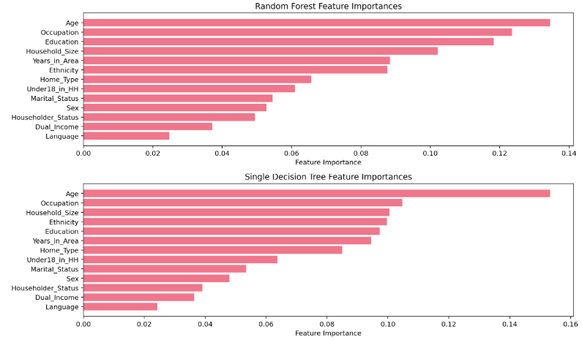
In terms of the rankings of the features there are many similarities, age and occupation remain the top 2 while language, dual income, householder status and sex remain at the bottom. There are very little shake ups in the order and those are in the middle. In terms of the values of the importances they are different because there are two different algorithms that are calculating the importance, part c is only using 1 tree based off the entire data while in part l it’s using 100 different trees which removes the bias that one tree could have if there is an outlier

- Predict the annual income of households in the test set using the Random Forest model. Calculate the prediction error and compare it to the error you obtained from the single decision tree in part (e). Which model performs better on the test set?
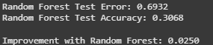
The random forest model performs better on the test set because it is using 100 decision trees as used in the last couple parts to calculate. This makes it so that it smooths out the predictions, because if some trees make mistakes the others can compensate

- Experiment with the number of trees in the forest. Train models with n_estimators = [10, 50, 100, 200] and plot the OOB error against the number of trees. At what point does the error seem to stabilize? What is the trade-off in using more trees?
The error stabilizes at 50-100 trees, and we know this because this is where you can start seeing diminishing returns (50 trees error = 0.185 100 trees error = 0.182). The trade-off in using more trees is that the positive is better accuracy and more stable predictions, but the negatives is that it takes longer to train, more memory usage and after a certain amount of trees you'll see diminishing returns

